Predicate Adjective as Subject Complement

✅ What Is a Predicate Adjective?
# Source: AI Source: Provided by: [Data Path: Persons Table -> ID Column: 1, Name_En Column: Motasem Essam] -> From: [ChatGPT] on [8/4/2025]
A predicate adjective is an adjective that follows a linking verb and describes the subject of the sentence. It is a type of subject complement because it completes the meaning of the subject by telling what it is like or what condition it is in.

🔸 Key Features:
# Source: AI Source: Provided by: [Data Path: Persons Table -> ID Column: 1, Name_En Column: Motasem Essam] -> From: [ChatGPT] on [8/4/2025]
- Follows a linking verb
(is, are, was, were, seem, become, feel, look, sound, etc.)
- Is an adjective
- Describes or modifies the subject

🔸 Examples of Predicate Adjective as Subject Complement:
# Source: AI Source: Provided by: [Data Path: Persons Table -> ID Column: 1, Name_En Column: Motasem Essam] -> From: [ChatGPT] on [8/4/2025]
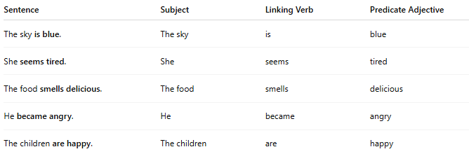
Sentence | Subject | Linking Verb | Predicate Adjective
The sky is blue. | The sky | is | blue
She seems tired. | She | seems | tired
The food smells delicious. | The food | smells | delicious
He became angry. | He | became | angry
The children are happy. | The children | are | happy

🔸 How to Identify:
# Source: AI Source: Provided by: [Data Path: Persons Table -> ID Column: 1, Name_En Column: Motasem Essam] -> From: [ChatGPT] on [8/4/2025]
Ask:
- What is the subject like?
- What word after the linking verb describes the subject?
If the word is an adjective that describes the subject, it’s a predicate adjective.

🔹 Comparison with Predicate Nominative:
# Source: AI Source: Provided by: [Data Path: Persons Table -> ID Column: 1, Name_En Column: Motasem Essam] -> From: [ChatGPT] on [8/4/2025]
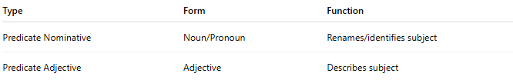
Type | Form | Function
Predicate Nominative | Noun/Pronoun | Renames/identifies subject
Predicate Adjective | Adjective | Describes subject

